COUNCIL ASSESSMENT REPORT
Panel Reference | PPSSWC-1
DA Number | x/38/2022
LGA | Blue Mountains City Council
Proposed Development | Removal of 8 demountable blocks and construction of a 2 storey classroom building with sports court, including the removal of 12 trees, associated landscaping and stormwater works, and upgrades to existing roads at
Street Address | St Columba's Catholic College, 168 Hawkesbury Road, SPRINGWOOD NSW 2777
Applicant/Owner | Applicant Amy Cropley DFP Planning/Owner Catholic Education Office Disocese of Parramatta
Date of DA lodgement | 24 January 2022
Total number of Submissions  Number of Unique Objections | - 1  - 1
Recommendation | Refusal
Regional Development Criteria (Schedule 7 of the SEPP (State and Regional Development) 2011 | Schedule 6(5)(b) of State Environmental Planning Policy (Planning Systems) 2021, being Private Infrastructure and Community Facilities Development that has a capital investment value of more than $5 million.
List of all relevant s4.15(1)(a) matters | - State Environmental Planning Policy (Planning Systems) 2021  - State Environmental Planning Policy (Biodiversity and Conservation) 2021  - Chapter 4 - Koala habitat protection 2021  - Chapter 8 - Sydney drinking water catchment  - State Environmental Planning Policy (Transport and Infrastructure) 2021  - Chapter 3 - Educational establishments and child care facilities  - State Environmental Planning Policy (Resilience and Hazards) 2021  - Chapter 4 Remediation of Land  - Local Environmental Plan 2015
List all documents submitted with this report for the Panel’s consideration | 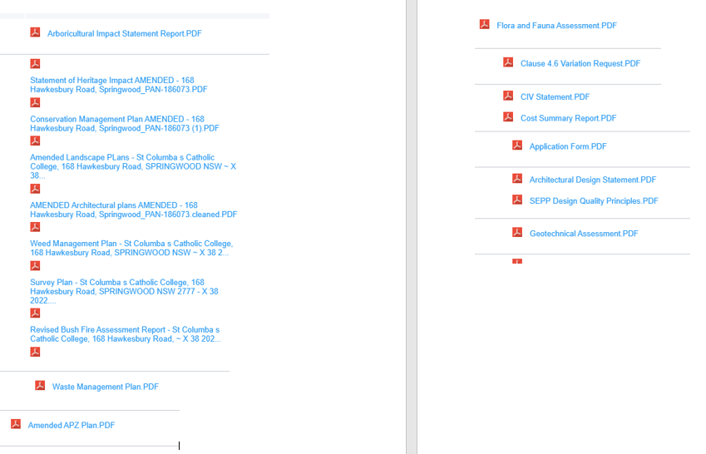
Clause 4.6 requests | Please list:  - Blue Mountains LEP 2015, Clause 4.3 height of Buildings
Summary of key submissions | - Pedestrian Access to school grounds from Hawkesbury Road
Report prepared by | Debbie Pinfold, Senior Development Assessment Planner  Alex Williams, Manager Development and Building Services  William Langevad, Director Environment & Planning Services
Report date | 22 November 2022
Summary of s4.15 matters  Have all recommendations in relation to relevant s4.15 matters been summarised in the Executive Summary of the assessment report? |  | Yes
Legislative clauses requiring consent authority satisfaction  Have relevant clauses in all applicable environmental planning instruments where the consent authority must be satisfied about a particular matter been listed, and relevant recommendations summarized, in the Executive Summary of the assessment report?  e.g. Clause 7 of SEPP 55 - Remediation of Land, Clause 4.6(4) of the relevant LEP |  | Yes
Clause 4.6 Exceptions to development standards  If a written request for a contravention to a development standard (clause 4.6 of the LEP) has been received, has it been attached to the assessment report? |  | Yes
Special Infrastructure Contributions  Does the DA require Special Infrastructure Contributions conditions (S7.24)?  Note: Certain DAs in the Western Sydney Growth Areas Special Contributions Area may require specific Special Infrastructure Contributions (SIC) conditions |  | No
Conditions  Have draft conditions been provided to the applicant for comment?  Note: in order to reduce delays in determinations, the Panel prefer that draft conditions, notwithstanding Council’s recommendation, be provided to the applicant to enable any comments to be considered as part of the assessment report |  | No

